La Loba’s Steak House Menu
“Strength of the Pack is the Wolf; Strength of the Wolf is the Pack”
-Rudyard Kipling
The Wolf Regions
- The Great Lakes: 8 Grilled Chicken Wings, in house made Buffalo Sauce $18
- Rustic Woods: Paella A La Valencia $22
- Sub Zero: Blackened Shrimp Avocado Cucumber Bites $15
- The Rockies: Red wine braised short rib; bed of sweet corn polenta $20
- The Wetlands: 6 Venison or Bison meatballs in a garlic tomato sauce $25
- Mid Atlantic: Two Chesapeake Blue Crab Cakes $20
- East Atlantic: 2 Jumbo Coconut Shrimp & 2 Jumbo Garlic Herbed Shrimp $22
The Wolf Hierarchy
- The Alpha Male: Pan seared & grilled 22oz T-bone, Asparagus and Roasted Broccoli $65
- The Alpha Female: 12oz Grilled Ribeye, peppercorn whisky sauce, roasted min potatoes $45
- The Beta Wolf: 10oz Butter & Herb basted sirloin, roasted corn and sweet potato $35
- The Subordinate Wolf: Grilled NY Strip, pat of garlic butter, pasta Carbonaro $45
- The Omega Wolf: Pan seared Filet Mignon, red wine sauce, vegetable medley $50
The Little Wolf
- The Newborn: Orecchiette mac n cheese with grilled chicken. $10
- The Pup: Chicken Parmesan on a bed of Fresh made Fettuccini $15
- The Teen: Grilled Steak Frites $15
- The young adult: Freshly ground Hamburger grilled with your choice of cheese and seasoned fries $15

The Wolf Habitat
- The Eastern Wolf: Grilled Salmon with avocado salsa on a bed of Fresh in-house made rice pilaf $55
- The Ethiopian Wolf: (Native to Ethiopia) Red Wine Braised beef tips with sweet potato mash $25
- The Grey Wolf: Pan Seared Filet Mignon with 4 Jumbo Shrimp $650or Lobster tail $75
- The Himalayan Wolf: Nepali Chicken Curry on bed of wild rice $22
- The Indian Wolf: Lamb Tikka Masala served with Steamed Vegetables and Rice Pilaf $25
- The Red Wolf: 2 Herb Roasted Pork Chops with Roasted Root Vegetables. $25
- The Arctic Wolf: Walnut Crusted halibut in a lemon wine sauce with roasted mix vegetables $32
The Wolf Morsels:
- Coconut Crème Brulee or Caffe Mocha Crème Brulee $18
- Skillet Brownie topped with ice cream $12
- Chocolate Gateau with Crème Anglaise $15
- Imprisoned Mini Vanilla Bean Cheesecake or Double Chocolate, caramel glaze $20
- Raspberry Amaretto Semifreddo, Fresh Raspberries, fresh mint $18
- White chocolate Junmai Sake Mousse, Citrus Udon, Junmai Sake Macerated Berries $25
- Goat Cheese Panna Cotta with a Guava Gelee $18

The Grasslands
- Fresh Spring Mix with Strawberries and fresh goat cheese $15
- Watermelon and Cress Salad with grilled shrimp and hearts of palm $15
- Avocado and Hearts of Palm with coriander vinaigrette $15
- Cesar Salad $15
- Arugula Pear Salad $15
- Peach Caprese Salad $15

The Water Truce
Fountain Drinks $2.50
Water $2 flavored $2.50
Fresh squeezed lemonade $3
Strawberry, Peach, or Raspberry

Spirits

Culinary Team
*Executive Chef/Owner
Eve Loftus
Sous Chef Pastry Chef Lead Line Cook Lead Pastry Cook

General Manager Catering Lead
Katerina Quintavollie

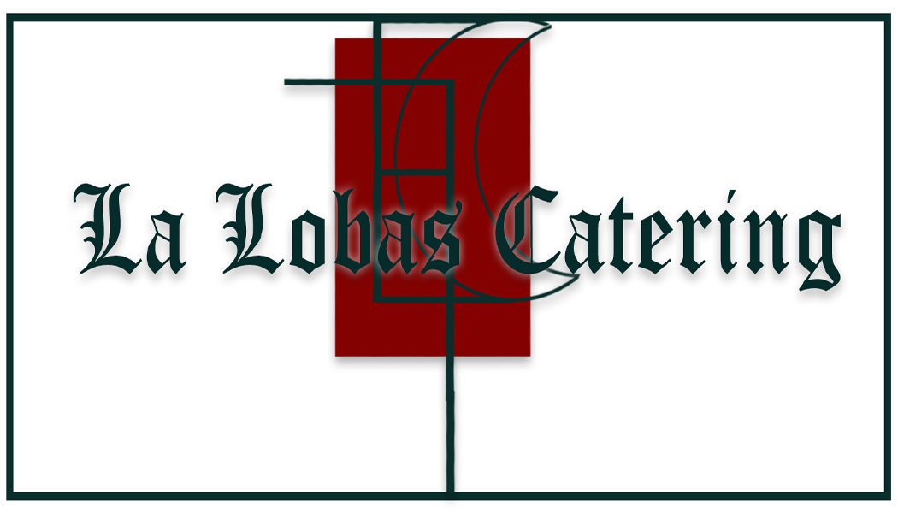
*Consumer Advisory: Consuming raw foods or undercooked meat, poultry, seafood and eggs may increase your risk of food borne illness; all items are cooked to order.

